# Home Objects detection using Mask RCNN

[Mask RCNN](https://arxiv.org/pdf/1703.06870.pdf) paper by Kaiming He’s team at facebook, a supervised learning neural network to detect, localize and pixelwise segment the objects in an image.

We will be using Mask RCNN to do following tasks:

1. Goal of this assignment is to detect, localize and semantic segment the home objects using Mask-RCNN on Keras, and TensorFlow. Both training and test dataset can be downloaded from [HOME OBJECT](http://www.vision.caltech.edu/pmoreels/Datasets/Home_Objects_06/) dataset. You are expected to annotate the data, augment training data and use resnet50 as a backbone encoder.
2. Mask RCNN uses multi-task loss function combines the losses of classification - Lcls, Localization - Lbox and segmentation - Lmask. You are encouraged to change the loss function of individual task and compare the results with the MaskRCNN loss functions.
3. Change optimizer to Adam
4. Check if you can improve prediction accuracy by test time augmentation.

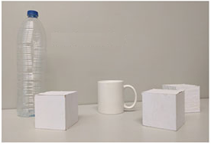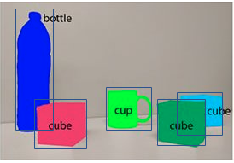

* 1. Test image b. Predicted image

Deliverables:

1. Video of home object detection with frame rate. Done
2. Report should consist about Task (a)
   * Tools used for annotation and augmentation Done
   * step by step process of training & inference Done
   * Explanation on Training Losses with graphs: Done
     + **rpn_class_loss**
     + **rpn_bbox_loss**
     + **mrcnn_class_loss**
     + **mrcnn_mask_loss**
     + **mrcnn_bbox_loss**
   * Training and inference speed Done
   * test accuracy results with graphs FUTURE WORK
   * If any room for improvements by changing the hyperparameters. In Progress

1. Report on task(b), brief explanation of your approach to different loss functions used and its results comparing to MaskRCNN loss functions . TODO
2. Report comparing Adam’s vs MaskRCNN optimizer. Done
3. Code Done
4. Annotated images for training. Done

You will be mainly graded on the analysis of using different loss functions, optimizers and improving the accuracy.